**LAB 8**

**Contact us form:**

<!DOCTYPE html>

<html>

<head>

<meta name="viewport" content="width=device-width, initial-scale=1">

<style>

input[type=text]{

width: 20%;

padding: 12px;

border: 1px solid #ccc;

border-radius: 4px;

margin-top: 6px;

margin-bottom: 16px;

}

input[type=submit] {

background-color: #04AA6D;

color: white;

padding: 12px ;

border: none;

margin-left: 20%;

}

.container {

border-radius: 5px;

background-color: #f2f2f2;

padding: 30px;

}

</style>

</head>

<body>

<div class="container">

<h2 style="background-color: rgb(124, 252, 192); " >Contact Us</h2>

<label for="fname" class="icon" >Full Name*</label><br>

<input type="text" id="fname" name="firstname" placeholder="Your name.." required>

<input type="text" id="lname" name="lastname" placeholder="Your last name.."required ><br>

<label for="lname">Email*</label><br>

<input type="text" id="Email" name="Email" placeholder="Your Email"required><br>

<label for="subject">Leave us a few words*</label><br><br>

<textarea id="subject" name="subject" placeholder="Write something.." style="height:200px" required ></textarea><br>

<input type="submit" value="Submit" style="margin-left: 20%;" >

</form>

</div>

</body>

</html>

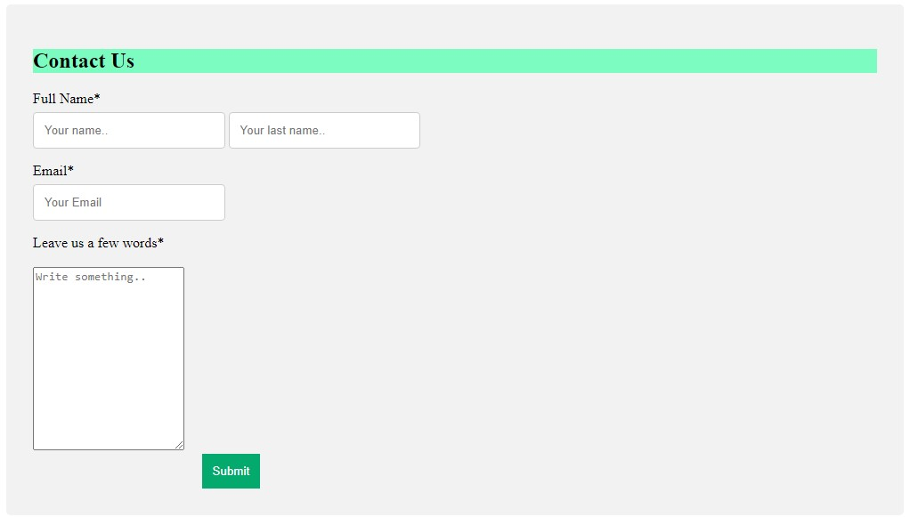

**SIGN UP FORM:**

<!DOCTYPE html>

<html lang="en">

<head>

<meta charset="UTF-8">

<meta http-equiv="X-UA-Compatible" content="IE=edge">

<meta name="viewport" content="width=device-width, initial-scale=1.0">

<title>Class 6</title>

<style>

input[type=text]{

width: 40%;

padding: 10px;

border: 1px solid rgb(59, 53, 53);

border-radius: 4px;

margin-top: 5px;

margin-bottom: 5px;

}

select{

width: 15%;

padding: 10px;

border: 1px solid #ccc;

border-radius: 4px;

margin-top: 5px;

margin-bottom: 5px;

}

.gen{

width: 15%;

padding: 10px;

border: 1px solid #ccc;

border-radius: 4px;

margin-top: 5px;

margin-bottom: 5px;

margin-inline: 10px;

}

</style>

</head>

<body>

<div>

<h1>Sign Up</h1>

<small style="color: gray;">Its quick and easy</small><br><br>

<input style="font-size: 20px; " type="text" placeholder="First name">

<input style="font-size: 20px;" type="text" placeholder="Surname"> <br> <br>

<input style="font-size: 20px;" type="text" placeholder="Mobile number or Email Address"> <br> <br>

<input style="font-size: 20px;" type="text" placeholder="New Password">

<p> Date Of Birth</p>

<select name="date" id="date">

<option value="">1</option>

<option value="">2</option>

<option value="">3</option>

<option value="">4</option>

<option value="">5</option>

<option value="">6</option>

<option value="">7</option>

<option value="">8</option>

<option value="">9</option>

<option value="">10</option>

<option value="">11</option>

<option value="">12</option>

<option value="">13</option>

<option value="">14</option>

<option value="">15</option>

<option value="">16</option>

<option value="">17</option>

<option value="">18</option>

<option value="">19</option>

<option value="">1992</option>

<option value="">1993</option>

<option value="">1994</option>

<option value="">1995</option>

<option value="">1996</option>

<option value="">1997</option>

<option value="">1998</option>

<option value="">1999</option>

<option value="">2001</option>

<option value="">2002</option>

<option value="">2003</option>

<option value="">2004</option>

<option value="">2005</option>

<option value="">2006</option>

<option value="">2007</option>

<option value="">2008</option>

<option value="">2009</option>

<option value="">2010</option>

<option value="">2011</option>

<option value="">2012</option>

<option value="">2013</option>

<option value="">2014</option>

<option value="">2015</option>

<option value="">2016</option>

<option value="">2017</option>

<option value="">2018</option>

<option value="">2019</option>

<option value="">2020</option>

<option value="">2021</option>

<option value="">2022</option>

<option value="">2023</option>

<option value="">20</option>

<option value="">21</option>

<option value="">22</option>

<option value="">23</option>

<option value="">24</option>

<option value="">25</option>

<option value="">26</option>

<option value="">27</option>

<option value="">28</option>

<option value="">29</option>

<option value="">30</option>

<option value="">31</option>

</select>

<select name="date" id="date">

<option value="">January</option>

<option value="">February</option>

<option value="">March</option>

<option value="">April</option>

<option value="">May</option>

<option value="">June</option>

<option value="">July</option>

<option value="">August</option>

<option value="">September</option>

<option value="">October</option>

<option value="">November</option>

<option value="">December</option>

</select>

<select name="date" id="date">

<option value="">1990</option>

<option value="">1991</option>

<option value="">2024</option>

<option value="">2025</option>

<option value="">2026</option>

<option value="">2027</option>

<option value="">2028</option>

<option value="">2029</option>

<option value="">2030</option>

</select>

<p> Gender </p>

<label class="gen">Female<input type="radio" > </label>

<label class="gen">Male<input type="radio" > </label> <br><br>

<small>By clicking sign Up you agree to our Terms Data policy and cookie policy you recive SMS <br>notification from us and can opt out any time</small><br>

<button style="color:white; font-size: large;background-color:green;margin-left: 15%;border-radius: 10%;border-color: green;width:20% ; " >Sign up</button>

</div></body></html>

